General Ledger Period Opening
General Ledger Super User
Setup
Open/Close

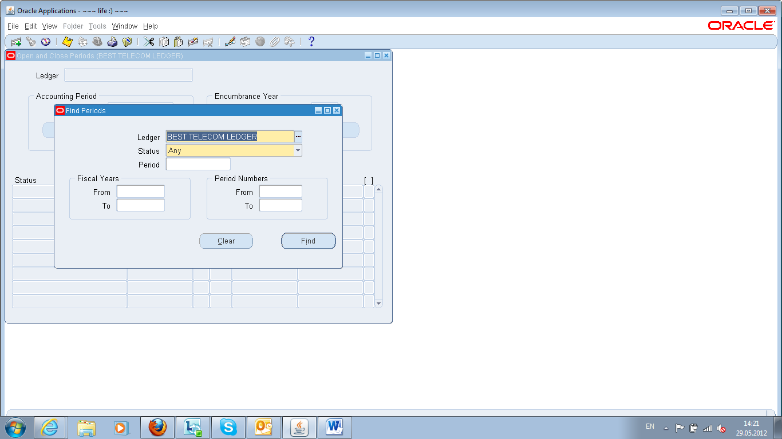
Press FIND

Press OPEN PERIOD
Chose the target period
Press OPEN

Opening Payables Module
Payables Setup BeST

Payables Manager Responsibility / Accounting / Control Payables Period (Legder Based)
Control Payables Periods
Choose the period you want to open, change the status to open
Save
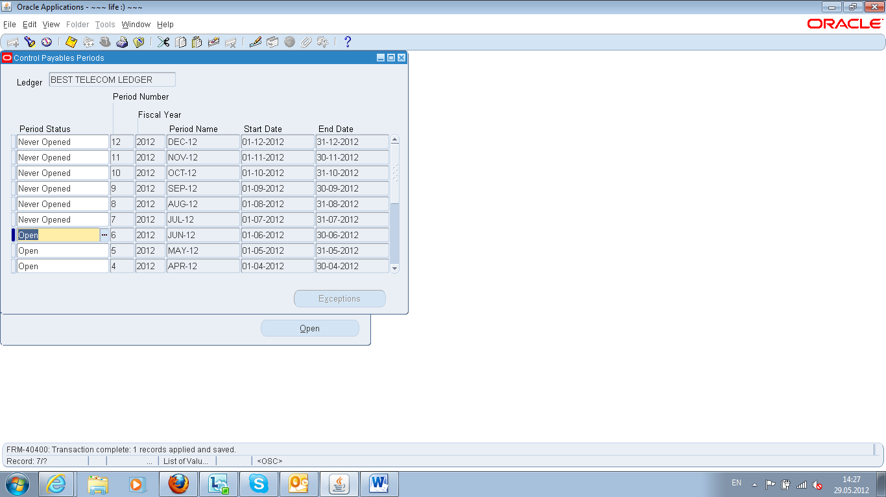

Opening Receivable Module
Receivables Setup BeST
Receivables Manager Responsibility / Control / Accounting / Open-Close Periods (Ledger Based)

Open/Close Periods
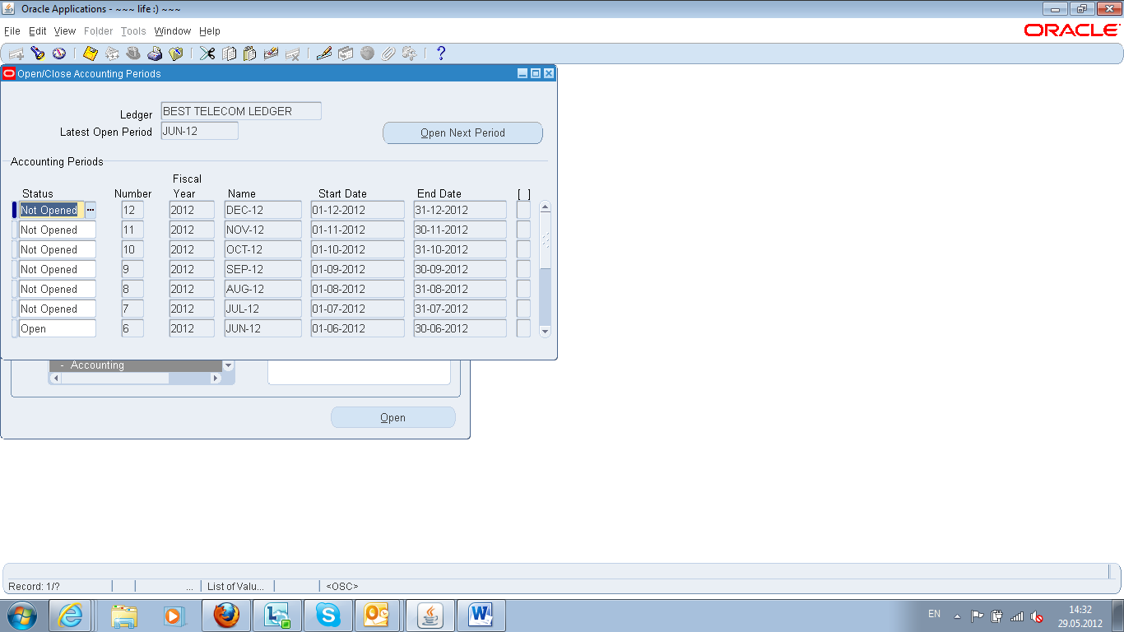
Choose the period you want to open, change the status to open
Save
Opening Purchasing Module
Purchasing Supper User BeST
Purchasing Responsibility / Setup / Financials / Accounting / Control Purchasing Periods
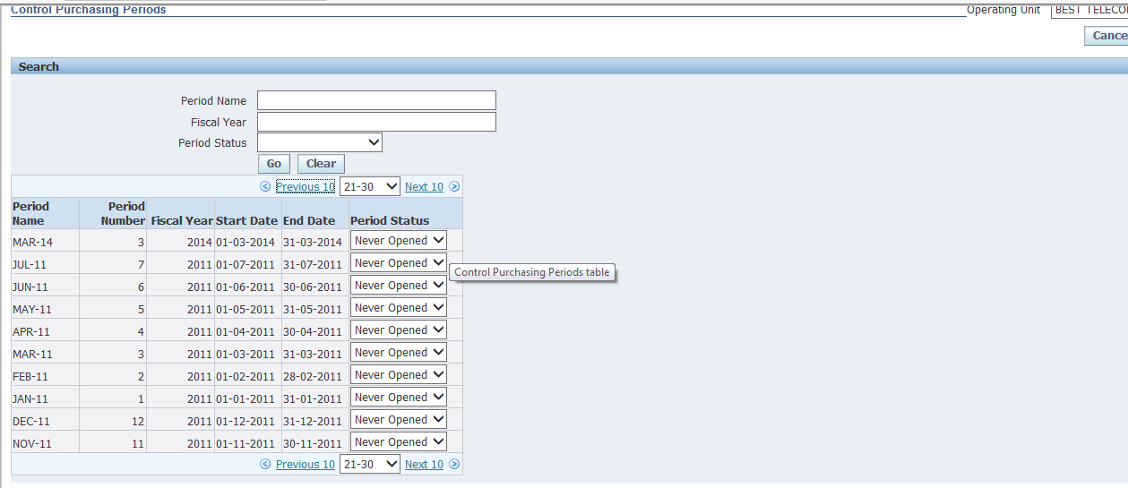
Choose the period you want to open, change the status to open
Save

Purchasing Responsibility / Setup / Financials / Accounting / Open and Close Periods (Ledger Based)
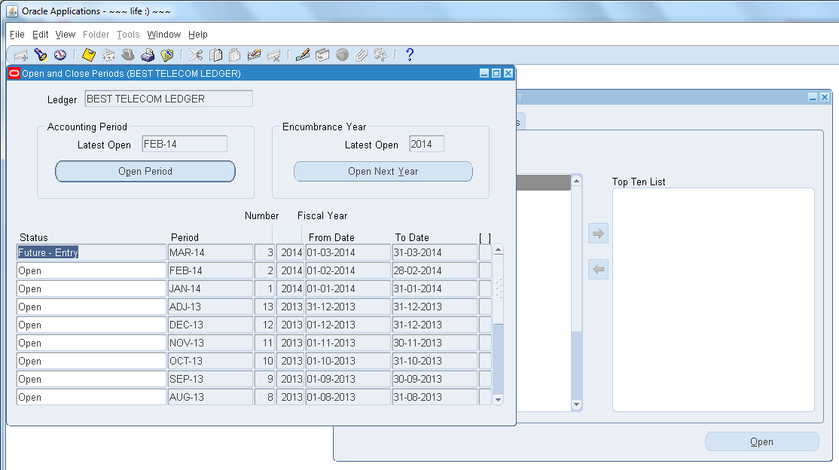

Choose the period you want to open, change the status to open
Save

Opening Inventory Module

Inventory Responsibility / Acc Close Cycle / Inv Acc Periods (ORG based) - !!!FOR EACH WAREHOUS E!!!

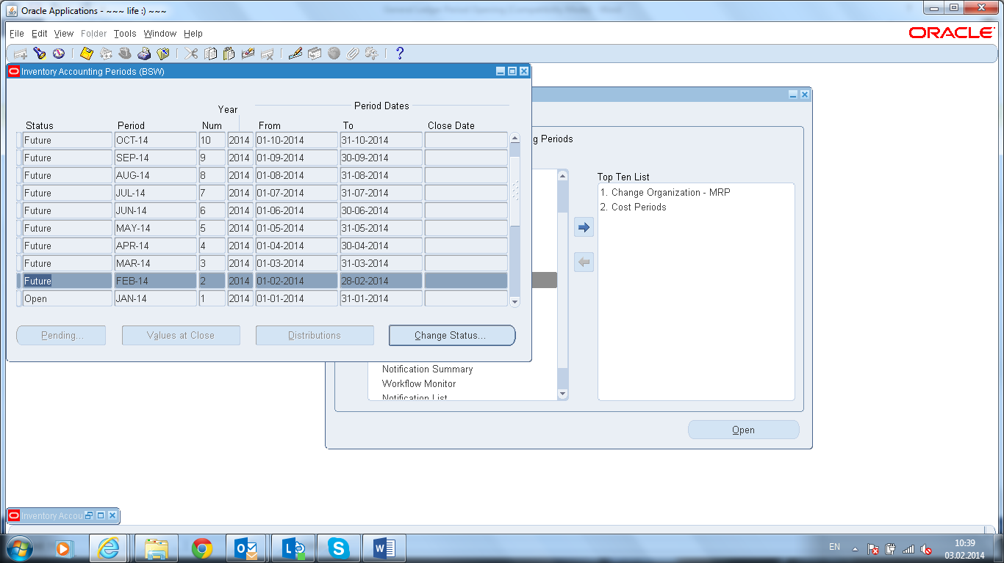
Close
--------------------------------
-- to clean interface
--------------------------------

select mti.* from inv.mtl_transactions_interface mti
where mti.transaction_date <= to_date('31.10.2018','dd.mm.yyyy')

delete from inv.mtl_transactions_interface mti -- Service Desk 231253
where mti.transaction_date <= to_date('31.10.2018','dd.mm.yyyy')

select * from inv.mtl_transaction_lots_interface mtli
where not exists (select * from inv.mtl_transactions_interface mti where mtli.transaction_interface_id = mti.transaction_interface_id)
and LAST_UPDATE_DATE <= to_date('31.10.2018','dd.mm.yyyy')

delete from inv.mtl_transaction_lots_interface mtli -- Service Desk 231253
where not exists (select * from inv.mtl_transactions_interface mti where mtli.transaction_interface_id = mti.transaction_interface_id)
and LAST_UPDATE_DATE <= to_date('31.10.2018','dd.mm.yyyy')

select * from inv.mtl_serial_numbers_interface msni
where not exists (select * from inv.mtl_transaction_lots_interface mtli where msni.transaction_interface_id = mtli.serial_transaction_temp_id)
and LAST_UPDATE_DATE <= to_date('31.10.2018','dd.mm.yyyy')

delete from inv.mtl_serial_numbers_interface msni -- Service Desk 231253
where not exists (select * from inv.mtl_transaction_lots_interface mtli where msni.transaction_interface_id = mtli.serial_transaction_temp_id)
and LAST_UPDATE_DATE <= to_date('31.10.2018','dd.mm.yyyy')

--------------------------------------
-- to clean pending transactions
--------------------------------------
select * from inv.mtl_material_transactions_temp mtt
where mtt.transaction_date <= to_date('31.10.2018','dd.mm.yyyy')

-- Service Desk 231253
delete from inv.mtl_material_transactions_temp mtt
where mtt.transaction_date <= to_date('31.10.2018','dd.mm.yyyy')

select * from inv.mtl_transaction_lots_temp mtlt
where not exists (select * from inv.mtl_material_transactions_temp mtt where mtt.transaction_temp_id = mtlt.transaction_temp_id)
and CREATION_DATE <= to_date('31.10.2018','dd.mm.yyyy')

-- Service Desk 231253
delete from inv.mtl_transaction_lots_temp mtlt
where not exists (select * from inv.mtl_material_transactions_temp mtt where mtt.transaction_temp_id = mtlt.transaction_temp_id)
and CREATION_DATE <= to_date('31.10.2018','dd.mm.yyyy')

select * from inv.mtl_serial_numbers_temp mst
where not exists (select * from inv.mtl_transaction_lots_temp mtlt where mtlt.serial_transaction_temp_id = mst.transaction_temp_id)
and CREATION_DATE <= to_date('31.10.2018','dd.mm.yyyy')

-- Service Desk 231253
delete from inv.mtl_serial_numbers_temp mst
where not exists (select * from inv.mtl_transaction_lots_temp mtlt where mtlt.serial_transaction_temp_id = mst.transaction_temp_id)
and CREATION_DATE <= to_date('31.10.2018','dd.mm.yyyy')

